Name:______________________________________________ Date:____________________ Class:___________________

U.S. History
Unit 8 Test
Turbulent Times- 1960s/1970s

Multiple Choice: Identify the choice that best completes the statement of answers the question.

- Which statements evaluate the impact of the Voting Rights Act of 1965 on democratic participation?
- The act succeeded because it allowed more citizens to vote.
- The act succeeded because it increased voting qualifications.
- The act failed because it did not loosen requirements for gaining citizenship.
- The act failed because it did not anticipate loopholes in legislative guarantees.

- This excerpt is from the Gulf of Tonkin Resolution approved by a Joint Resolution of Congress in 1964.
How did this resolution expand the president’s executive power?
That the Congress approves and supports the determination of the President, as Commander in Chief, to take all necessary measures to repel any armed attack against the forces of the United States and to prevent further aggression.
- By sanctioning presidential leadership of relief efforts for needy nations.
- By expanding presidential authority to negotiate treaties with hostile nations.
- By permitting presidential commitment of military troops without a formal declaration of war.
- By requiring presidential accountability for military spending without an authorized budget for defense.

- Chief Justice Earl Warren wrote the opinion in the United States Supreme Court case of Brown v. Board of Education of Topeka.
In approaching this problem, we cannot turn the clock back to 1868, when the [14th] Amendment was adopted, or even to 1896, when Plessy v. Ferguson was written. We must consider public education in the light of its full development and its present place in American life throughout the Nation.
What does Chief Justice Warren’s opinion indicate about the United States Constitution?
- Judges rely on precedents for guidance.
- Legislators foresaw the necessity of rewriting laws.
- Key principles should be reinterpreted as society changes.
- Fundamental truths may be understood as originally intended.

- Why did the Black Panthers and the American Indian Movement use different tactics in the pursuit of equal rights than the followers of Dr. Martin Luther King Jr?
- They were more interested in forming coalitions.
- They were less interested in gaining economic power.
- They believed earlier tactics were ineffective in achieving goals.
- They believed earlier tactics were effective in gaining public support.

- How does the Brown v. Board of Education decision demonstrate that the Constitution is a living document?
- The case overturned a previous Supreme Court ruling.
- The case contributed to expanded media coverage of current events.
- The case declared that a legislature could reverse its previous policies.
- The case allowed the Supreme Court to overturn an unfair conviction.

- This list describes several events during the Civil Rights Movement.

What do these events indicate about the government response to the Civil Rights Movement?
1957- Federal troops enforce integration of an Arkansas high school.

1964- Civil Rights Act forbids discrimination in public facilities.

1965- Voting Rights Act forbids literacy test for voters.

- The federal government continued to encourage social activism.
- The state government actively upheld constitutional protections.
- The state governments continued to promote political participation.
- The federal government actively secured constitutional guarantees.

- Why did Stokely Carmichael’s rhetoric differ from that of other civil rights advocates?
- He was dissatisfied with the focus on social activism.
- He was disappointed with the qualification of minority leaders.
- He was dissatisfied with the emphasis on civil disobedience in the face of violence as a means to achieve social equality.
- He was disappointed with the involvement in economic boycotts of public services as a means to achieve economic quality.

- Why did leaders of the Civil Rights Movement oppose the use of poll taxes?
- The tax funds for political candidates.
- The tax offset reductions in property ta rates.
- The tax used political participation to raise funds.
- The tax used economic ground to exclude voters.

- In 1957 this telegram was sent to President Dwight Eisenhower from the Mayor of Little Rock, Arkansas.
The immediate need for federal troops is urgent. The mob is much larger in numbers at 8am than at any time yesterday… Situation is out of control and police cannot disperse the mob…Action by you restore peace and order and compliance with your proclamation.
Why was it important for the federal government to respond to this situation?
- The federal government wanted to appease voters in Southern states.
- The federal government needed to demonstrate it would enforce the law.
- The federal government wanted to promote political participation in Southern states.
- The federal government needed to prove it would halt protest by civil rights activist.

- During the Vietnam War, how did the lack of censorship of television reports affect the public’s perception of the war?
- By allowing the public to consider different viewpoints concerning the war.
- By instructing the public to organize protests actively resisting the war.
- By prompting the public to ignore the criticism of the war.
- By causing the public to doubt the severity of the war.

- In the 1960s, women campaigned for an end to discrimination based on gender.
In the 1960s, there were many examples of gender-based discrimination. Classified ads for employment were separated by gender in newspaper. Most women were unable to borrow money at a bank without a male cosigner. Seventy-five percent of the women who worked were saleswomen, clerks, factory, laborers, or housekeepers.
Based on this information, which area describes a common goal for progress in the women’s rights movement and the African American Civil Rights Movement?
- Voter registration
- Social democracy
- Educational Access
- Economic opportunities

- Which statement became a slogan for the Civil Rights Movement following the March on Washington in 1963?
- “I have a dream!”
- “A Brave New World”
- “Give Peace A Chance”
- “Back to the drawing board”

- Which statement evaluates the impact of the Selma to Montgomery marches on the expansion of voting rights?
- The marches aided the movement by promoting reform at the state level.
- The marches hindered the movement by provoking backlash at the local level.
- The marches aided the movement by rallying support among national politicians.
- The marches hindered the movement by interfering with reform measures in progress.

- This is a description of changes during the Civil Rights Movement.

In 1960 only 5% of Mississippi’s African American population was registered to vote. By 1968, 60% of the African American population was registered to vote. Other southern states showed similar change. Between 1965 and 1990, the number of African American state legislators and members of Congress increased from 2 to 160.
Which factor increased African American political influence between 1960 and 1990?
- Laws that forbade discriminatory hiring practices.
- Policies that ended discrimination in the workplace.
- Court cases that ended segregation in public schools.
- Legislation that removed unfair electoral requirement.

- This newspaper headline was published in 1964.

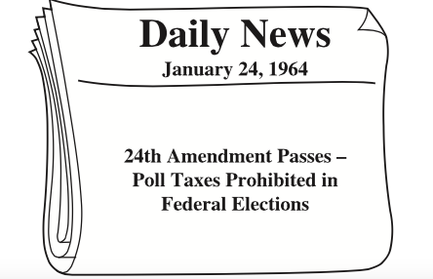

Which obstacle to voting was addressed by the 24th Amendment?
- Poverty
- Literacy
- Geography
- Citizenship

- President Lyndon Johnson made this statement in 1964.
We have the opportunity to move not only toward the rich society and the powerful society, but upward to the Great Society.
How did this policy differ from the New Deal?
- It attempted to address the underlying causes of poverty.
- It attempted to conserve the nation’s natural resources.
- It promoted economic opportunities for women.
- It promoted cultural programs in rural areas.

- One method used by African Americans such as Martin Luther King, Jr., to oppose segregation during the 1950s and 1960s was
- Civil Disobedience
- Armed robbery
- Prohibition
- Armistice

- In 1963 Governor George Wallace made this statement while opposing integration at the University of Alabama.
I claim today for all the people of the State of Alabama those rights reserved to them under the Constitution of the United States. Among those powers so reserved and claimed is the right of state authority in the operation of. …colleges and University.
What was Governor Wallace’s justification for attempting to block racial integration at the University of Alabama?
- The school was unwilling to accept federal funds for state colleges.
- The federal government had illegally taken a power reserved to the states.
- National Guard capability was too small to control violent actions by angry crowds.
- African American students had been given preferential treatment in selecting schools.

- In 1955 Rosa Parks, an African American women, refused to give up her seat on a bus to a white man. What was the significant about Park’s refusal and arrest?
- It led to the Supreme Court’s anti-segregation decision in Brown v. Board Education.
- It led to the states’ rights versus national law showdown in Little Rock, Arkansas.
- It led to the Montgomery bus boycott and the Supreme Court ruling against the Montgomery bus segregation law.
- It led to the end of nonviolent protest in the civil rights movement.

- Under Gerald Ford’s administration, the economy suffered from
- Boom and Bust
- Stagflation
- Terrorism
- Depression

- Which constitutional issue was debated after the release of the Pentagon Papers?
- Freedom of religion
- The right to a jury trial
- Freedom of the press
- The right to peaceful assembly

- What Supreme Court decision eliminated segregation in schools?
- Brown v. Board of Education
- Abington School District v. Schempp
- Mapp v. Ohio
- Escobedo v. Illinois

- Voting rights improved for African Americans when which amendment eliminated poll taxes in federal elections?
- Twenty-second Amendment
- Twenty-third Amendment
- Twenty-fourth Amendment
- Twenty-fifth Amendment

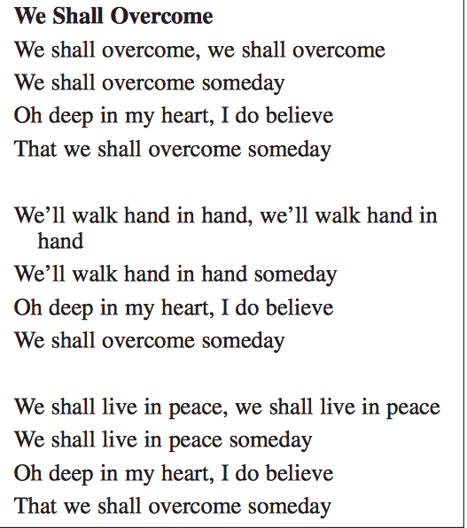

What can songs such as this one, popular with civil rights protestors in the 1960s, reveal to historians?
- Protest events
- Various reforms protestors wanted to see
- The level of anger and unrest in the 1960s
- The broad goals and dreams of the protestors

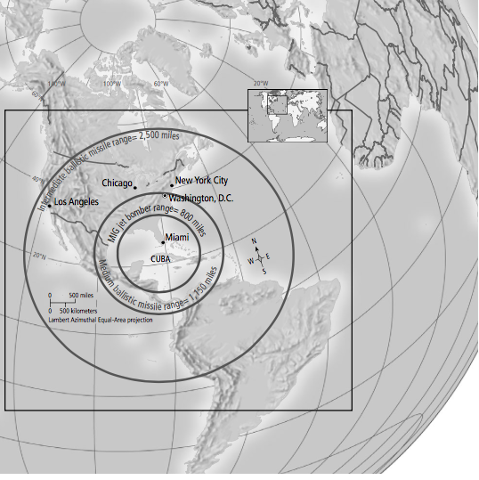

According to the map, why did John F. Kennedy consider Cuba’s building of missile sites to the United States?
- Nuclear weapons were new and dangerous.
- The Cuban missiles were untested.
- Nuclear weapons could reach the United States.
- Nuclear weapons could not reach the United States.

“On February 1, 1960, four friends entered the Woolworth’s. They purchased school supplies and then sat at the lunch counter and ordered coffee. When they were refused service, [Ezell] Blair [one of the students] said, “ I beg your pardon, but you just served us at [the checkout] counter. Why can’t we be served a the counter here? The students stayed at the counter until it closed, then announced that they would sit at the counter every day until they were given the same service as white customers.”

The above passage describes which of the following?
- The Freedom Riders
- Labor union strikes
- Japanese internment
- The sit-in movement

- President John F. Kennedy’s domestic agenda was known as the
- The Great Society
- New Frontier
- Space Race
- New Deal

- The Tet Offensive demonstrated to Americans that
- The Vietcong won a major victory.
- The Vietcong War was almost over.
- The Vietcong was stronger than expected.
- Their soldiers pillaged and burned villages.

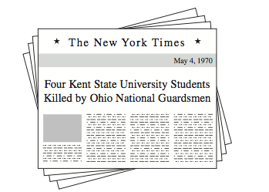

The event described in this headline resulted in
- Decreased federal funding of student loans.
- Increased support for the antiwar movement.
- The reinstatement of the draft.
- An end to federal investigation of student organizations.

- The domino theory, which provided the basis for U.S. entry into the Vietnam War, was the belief that intervention was necessary to prevent
- The rise of China as a dominant economic power.
- The loss of UN military bases in Asia.
- The inclusion of Taiwan in the Warsaw Pact.
- The expansion of communism across Southeast Asia.

- During the mid-1960s, U.S. participation in the Vietnam War resulted in
- Public support for an expanded military draft.
- Mandatory rationing of consumer goods.
- Mass demonstration by groups protesting the war.
- National attention for a third-party presidential candidate.

- The primary reason given by U.S. leaders to justify military involvment in Vietnam was that it would
- Promote reconstruction after World War II.
- Maintain the policy of détente.
- Fulfill prior United Nations obligations.
- Keep communism from spreading throughout the region.

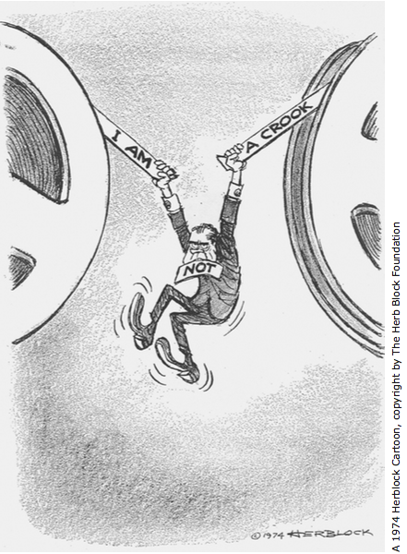

The incident illustrated by this cartoon increased cynicism toward the U.S. government because
- The press secretary failed to keep the public informed of national policy changes.
- The president directed a conspiracy to mislead the nation.
- The Supreme Court overruled statutes that defined confidentiality.
- Congress failed to pass legislation enforcing protection of privacy rights.

- A major goal of President Lyndon B. Johnson’s Great Society program was to
- Reduce poverty in the United States.
- Create a space program.
- Cut domestic programs to balance the budget.
- Contain communism in Southeast Asia.

- Base your answer to question 35 on the cartoon below and on your knowledge of social studies.

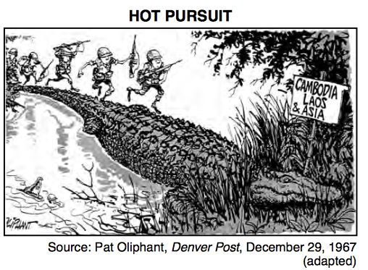

What is the main idea of this 1967 cartoon?
- Desertion by United States soldiers was widespread.
- The domino theory no longer applied to Southeast Asia.
- The United States policy of expanding the war in Indochina would be filled with hazards.
- A bridge into Laos and Cambodia helped United States soldiers invade Asia.

- Which of the following is most characteristic of the Cold War?
- The growth of nuclear arsenals in the United States and the Soviet Union.
- The expansion of national borders by imperialistic European countries.
- The implementation of isolationist foreign policies in Great Britain and China.
- The rapid industrialization of many Southeast Asian countries.

- Which of these best explains why worldwide reactions to U.S. involvement in Vietnam grew increasingly hostile during the late 1960s and early 1970s?
- The United States was viewed as appeasing a brutal dictator.
- The United States demanded the unconditional surrender of Ho Chi Minh.
- The United States was viewed as an aggressor invading an underdeveloped nation.
- The United States ignored a United Nations Security Council resolution to cease hostilities.

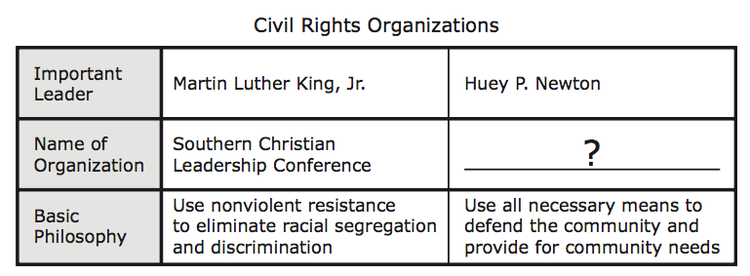

Which organization’s name correctly completes this table?
- Nation of Islam
- Black Panther Party
- Congress of Racial Equality
- NAACP

- One action that influenced the U.S.-Soviet signing of the SALT I treaty in 1972 was President Richard Nixon’s-
- Opening of diplomatic relations with China.
- Involvement in the Watergate scandal.
- Support of Israel during the Yom Kippur War.
- Withdrawal of military forces from Vietnam.

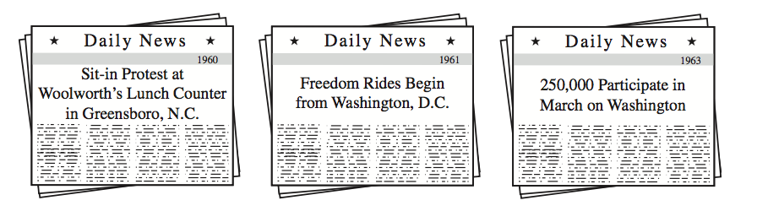
What was the main result of the events referred to in these headlines?
- The growth of insurance and welfare programs for elderly citizens.
- The growth of radical political parties on the East Coast.
- The expansion of political and economic opportunities for minority citizens.
- The expansion of economic cooperation between northern and southern states.

- How did press coverage of events during the Vietnam War affect the United States?
- Film footage from the front lines increased congressional support for the war.
- Reporting on military setbacks contributed to public disillusionment with the war.
- Increased U.S. media presence overseas resulted in overwhelming international support for U.S. intervention.
- Live presidential press conferences led to decline in partisan politics in Congress.

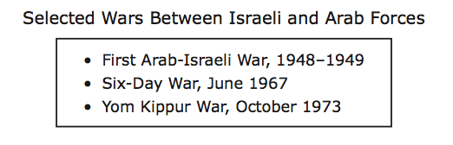
How did President Jimmy Carter attempt to end hostilities between the groups that fought these wars?
- He deployed U.S. troops to defeat the Palestine Liberation Organization.
- He ordered the boycott of the Olympic games in Moscow.
- He threatened to sever diplomatic ties with Syria.
- He helped negotiate a peace treaty known as the Camp David Accords.

- Why did gasoline prices spike during the 1970s and early 1980s?
- A natural disaster impeded offshore drilling for oil.
- Congress imposed new regulations on foreign energy companies.
- Conflicts in the Middle East disrupted the distribution of oil.
- Congress introduced new legislation to increase the fuel efficiency of vehicles.

- President John F. Kennedy responded to reports that the Soviet Union was constructing missile sites in Cuba by-
- Ordering a naval blockade of Cuba.
- Asking Congress to declare war on Cuba.
- Authorizing military strikes on strategic targets in Cuba.
- Seeking United Nations approval for economic sanctions against Cuba.

- President Richard Nixon’s foreign policy of dètente was an attempt to
- Resolve Middle East conflicts
- Improve relations with the Soviet Union
- Defend United States interests in Latin America
- Increase the power of the United Nations Security Council

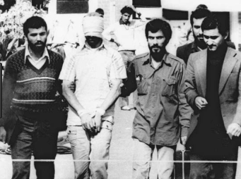

Which event in American history, during President Carter’s Administration does the photograph above represent?
- Cuban Missile Crisis
- Iran-Contra Scandal
- Iran Hostage Crisis
- March on Washington

- This poster is from the first annual Earth Day in 1970.

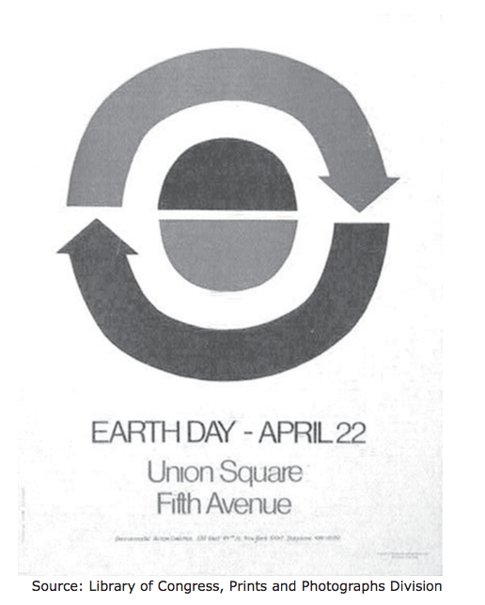

Earth Day was created for the purpose of
- Celebrating the diversity of humankind
- Honoring the world’s agricultural workers
- Raising awareness of environmental issues
- Promoting peace throughout the world

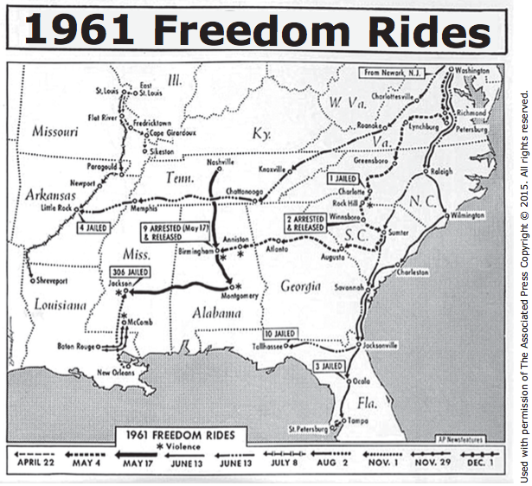
What was the goal of the protests depicted on this map?
- To pressure Congress to prohibit discrimination against disabled citizens
- To demonstrate the economic impact of discriminatory practices on interstate transportation
- To challenge the federal government to enforce Supreme Court ruling against discrimination in interstate transportation
- To persuade states to abandon discriminatory voter-registration procedures

- This is a poster for Woodstock in 1969.

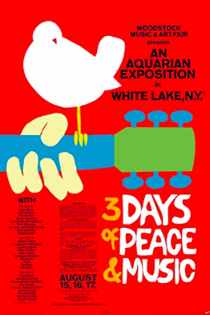

This poster best represents-
- Counterculture
- Beatnik
- Silent Majority
- The Great Society

- This is an excerpt from the Supreme Court’s ruling in Boynton v. Virginia in 1960s.

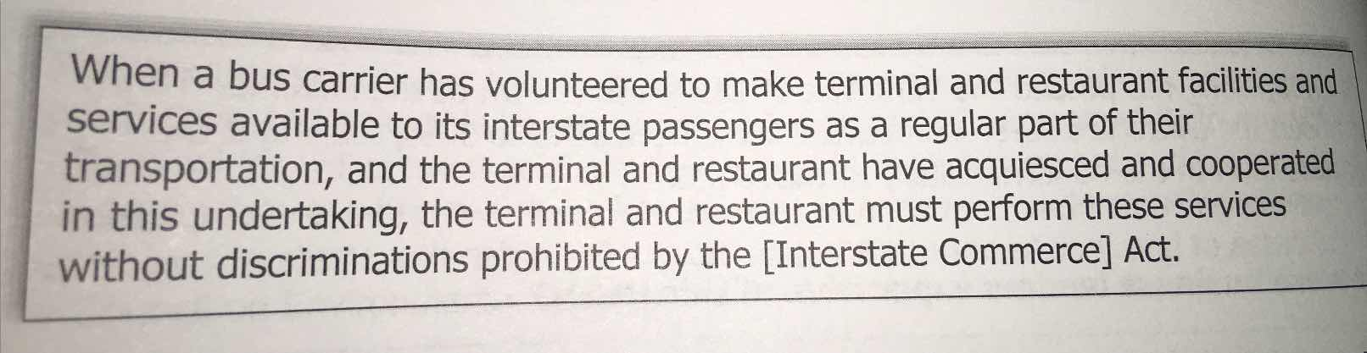

During the Civil Rights Movement, what strategy was used to enforce this ruling?
- Freedom Rides
- Freedom Summer
- March on Washington
- Montgomery Bus Boycott

