Name:____________________________________________________________________________________Date:_______________________

U.S. History
Semester Exam

Multiple Choice: Identify the choice that best completes the statement of answers the question.

- Few restrictions were placed on immigration to the United States in the late 19th century primarily because immigrants
- Would work for low wages.
- Provided a rich source of investment.
- Would add to the diversity of the population.
- Faced little opposition from citizens.

- What idea was aimed at creating an economic change that Populist believed would benefit farmers and those in debt?
- The adoption of the gold standard.
- The expansion of the money supply based on silver.
- The adoption of a trickle-down tax cut.
- The use of federal deficit spending to create jobs.

- This flowchart shows some events of the late 1800s.

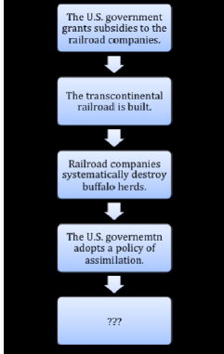

Which idea completes this chart?
- Native Americans are granted citizenship rights.
- Native Americans experience an economic and cultural decline.
- Railroads companies increased safety standards.
- Gilded Age business leaders did not support capitalism.

- In 1906 Upton Sinclair’s novel The Jungle described the meatpacking industry.

There was never the least attention paid to what was cut up for sausage; there would come all the way back from Europe old sausage that had been rejected, and what was moldy and it would be dosed with borax and glycerin, and dumped into the hopper, and made over again for home consumption.
-The Jungle, Chapter 14

Which statement explains how Upton Sinclair contributed to shaping perceptions about federal government power?
- He called for national training standards for workers.
- He encouraged farmers to form a government agency.
- He demonstrated the need for a national food supplier.
- He influenced public demand for government regulation of food.

- Which statement describes the role played by the U.S. journalists during the Spanish-American War?
- Journalists provided frequent reports of the fighting, allowing the public to follow a foreign war closely for the first time.
- Journalists focused on bad news rather than good news in order to criticize the decisions made by the president and military leaders.
- Journalists ignored the signs of impending war until it was too late to inform the public of the government’s intentions to declare war on Spain.
- Journalists exaggerated events to build support for the war, giving the president and Congress little chance to resolve the conflict diplomatically.

- In 1897, when artist Frederic Remington wired William Randolph Hearst that all was quiet in Cuba, Hearst reportedly sent the following wire.

Please remain. You furnish the pictures, and I’ll furnish the war.

What does this story indicate about the role of United States newspapers at that time?
- They were dedicated to accurate reporting.
- They were vital in conducting foreign diplomacy.
- They were concerned about international opinion.
- They were important in influencing government policy.

- The Roosevelt Corollary was meant to
- Settle international conflict in Asia.
- Support building of the Panama Canal.
- Discourage European interference in the Western Hemisphere, specifically Latin America.
- Provide Cuba’s independence from the U.S.

- This cartoon depicts President Theodore Roosevelt’s involvement with a national scandal.

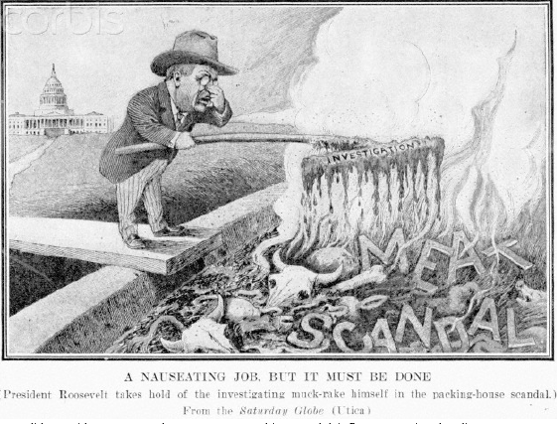

How did President Roosevelt’s response to this scandal influence national policy?
- The government became involved in protecting individuals from big businesses.
- The government became involved in providing basic needs for individuals.
- The government began providing agricultural subsides.
- The government began protecting natural resources.

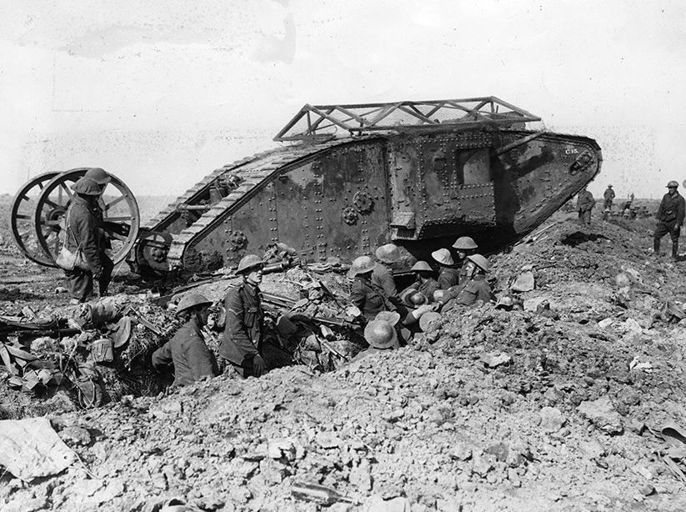
How did the military innovation shown in this photograph affect the course of World War I?
- It helped transport large number of troops off the battlefield.
- It helped break the stalemate of trench warfare.
- It made communications with officers on the front lines possible.
- It made the use of land mines obsolete.
- This timeline documents major events in United States involvement in World War I.
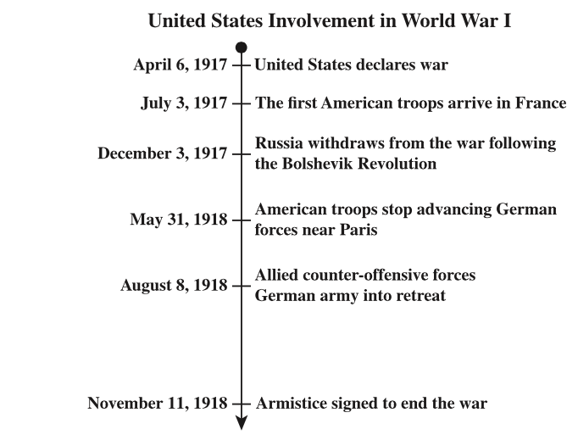

Which conclusion can be drawn from the timeline?
- Germany proposed a separate peace settlements with the United States.
- The transfer of German forces away from Russia weakened the Allies.
- The entry of the United States into the war contributed to the Allied victory.
- Russia withdrew from the war in order to clear the way for a French victory.

- The 1917 poster depicts a worker in a shipyard.

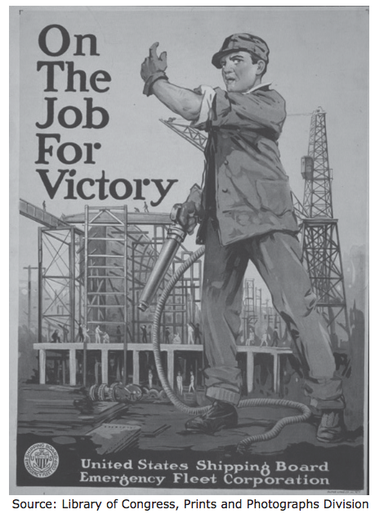

This poster could be used to support which assertion?
- Demand for labor in war industries helped increase employment.
- Use of new war technologies required extensive training.
- Conscription caused a shortage of laborers during wartime.
- Standardization of parts helped streamline the production of munitions.

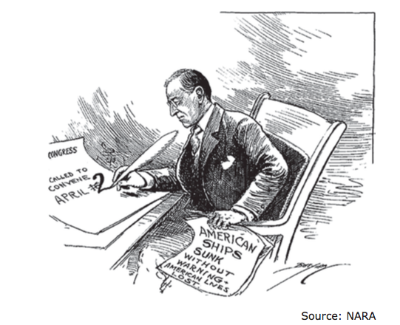

This cartoon depicts President Woodrow Wilson calling on Congress to
- Ratify the Treaty of Versailles
- Issue a declaration of war against Germany
- Authorize the use of funds to support Russian revolution
- Enact trade sanctions against Germany

- Which agency encouraged companies to use mass-production techniques?
- National War Labor Board
- Food Administration
- Committee on Public Information
- War Industries Board

- Analyze the cartoon and answer the question
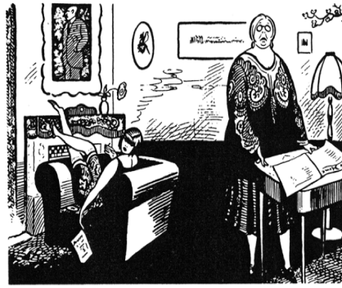

“ Mother, when you were young, didn’t you find it a bore to be sober and not smoke?’

Whose viewpoint is best symbolized in this cartoon?
- The feminists Lucretia Mott and Elizabeth Cady Stanton
- The flapper generation of the 1920s
- The Christian fundamentalist movement of the 1920s
- The muckrakers of the Progressive Era
- In 1919 Justice Oliver Wendell Holmes summarized the opinion of the Supreme Court in Schenck v. United States.

The question in every case is whether the words used are…to create a clear and present danger that… will bring about the substantive evils that Congress has a right to prevent… When a nation is at war, many things that might be said in time of peace… will not be endured so long as men fight, and…no Court could regard them as protected by any constitutional rights.

How did this ruling alter behavior within United States society?
- Public debates concerning issues of national security were no longer tolerated.
- Critical comments regarding the governing party were no longer tolerated.
- Legal scholars were targets of investigations during national crises.
- Civil liberties were subject to interpretation during national crisis.

- Which idea formed the basis of the debate in the 1925 Scopes Trial?
- The traditionalist belief that science was superior to religion
- The fundamental belief that science could co-exist with religion
- The modernist view that academics should be free of religious influence
- The social philosophy that students should abandon religious teachings

- The photograph shows a common form of entertainment in the 1920s.

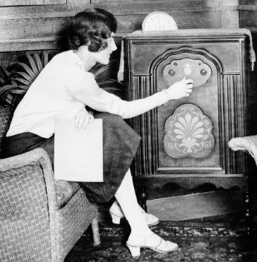
The photograph could be used in a museum exhibit about which trend in American history?
- Rise of mass culture
- Rise of a youth-based counterculture
- Role of urbanization in preserving traditional culture
- Role of immigrants in the formation of urban culture

- The best describes the Harlem Renaissance in the 1920s?
- An outpouring of Black artistic and literary creativity
- Governmental efforts to beautify impoverished urban areas
- The establishment of desegregated urban cinemas
- The birth of NAACP and the Civil Rights Movement

- Which of the following was a defining characteristic of the United States during the 1930s?
- A sharp increase in the power given to state governments
- An extended period of economic depression
- The adoption of an interventionist foreign policy
- The formation of a national civil rights

- Based your answer on the cartoon below and on your knowledge of social studies.
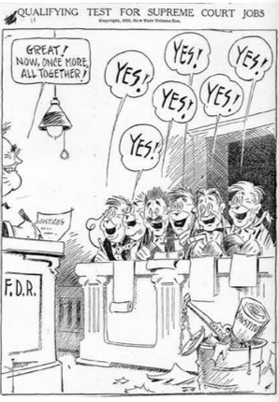
The main idea of the cartoon is that President Franklin D. Roosevelt wanted to
- Impeach justices who did not support him
- Control the decisions of the Supreme Court
- Create higher qualifications for justices
- Encourage the Supreme Court to act more efficiently

- This statement was made by President Franklin Delano Roosevelt.

Not only our future economic soundness but also the very soundness of our democratic institutions depends on the determination of our government to give employment to idle men.

What action did President Roosevelt take to implement the philosophy expressed in this statement?
- Implementing the Social Security Administration
- Conducting weekly fireside chats
- Declaring a national banking holiday
- Establishing the Civilian Conservation Corps

- This political cartoon published during the 1930s depict President Roosevelt as a magician.

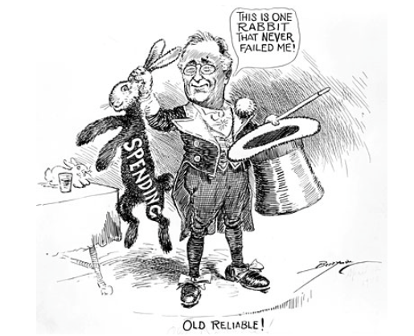

With which idea would the cartoonist agree?
- President Roosevelt needed to have more control over government spending
- Deficit spending was underutilized as a way to repair the economy
- President Roosevelt used many different approaches to solve the Depression
- Creating jobs through deficit spending gave the illusion of economic growth, but not real recovery

- Which of these factors contributed most to the Dust Bowl?
- Flash flooding and intense deforestation.
- High winds and railroads construction.
- Severe heat and rapid suburban development.
- Prolonged drought and poor farming practices.

- This chart shows simple projects done by a few New Deal agencies.

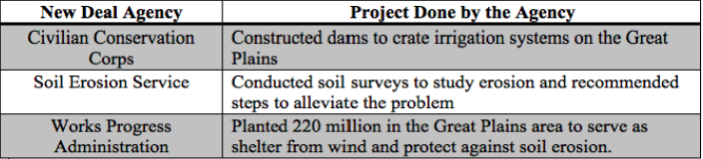

Which problem during the Great Depression did these agencies address?
- The lack of employment opportunities for artists and writers
- The need for electricity in southern states
- The environmental conditions that led to the Dust Bowl
- The loss of funding for national parks and recreation area

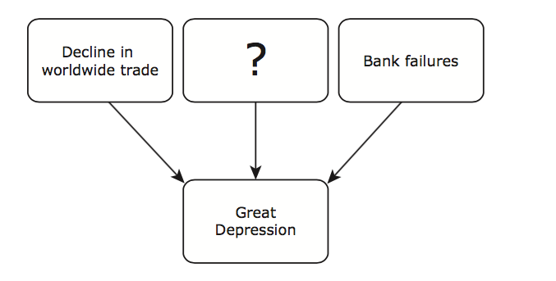

Which of the following best completes this graphic organizer?
- Increase in consumer spending
- Over speculation in the stock market
- Decrease in military spending
- Government subsidization of agriculture

- This statement could have been made by a historian.

What action from World War II would support this statement?
- Large numbers of women went to work in factories war goods
- Japanese Americans on the West Coast were forced into internment camps
- Citizens were encouraged to ration food and recycle materials that could be used overseas
- Significant portions of the African American population moved to northern cities

- The quote below comes from the Supreme Court ruling in Korematsu v. United States, handed down in 1944

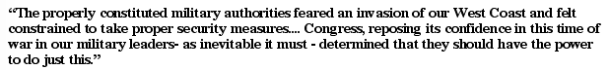

What security measures are being referred to in this case?
- Internment of Japanese Americans
- Dropping of the Atomic Bomb on Japan
- Deportation of all recent immigrants
- Exclusion of Japanese Americans from the draft

- The scientist working on the Manhattan Project during World War II were responsible for
- Deporting of most Japanese aliens to Japan
- Building satellites to spy on the Axis nations
- Creating materials for biological and chemical warfare
- Developing the Atomic bomb

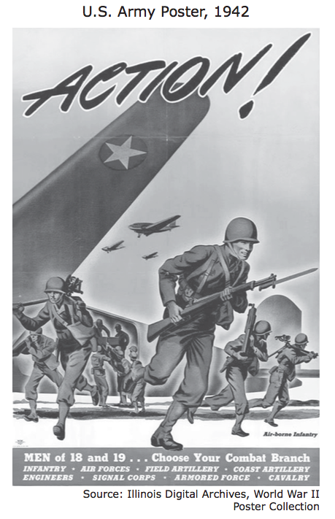

The U.S. Army distributed posters like this one with the goal of encouraging
- The sale of war bonds
- Young men to voluntarily enlist
- The creation of a selective service
- Young men to return to school

- During World War II, the United States transitioned to wartime production.

Military equipment made in the United States during World War II

-300,000 aircrafts
-5,000 cargo ships
-60,000 landing craft
-86,000 tanks

Which effect of this transition led to rationing in the United States during the war?
- The increase in military manufacturing affected the availability of employment
- The shift to making military goods affected the availability of civilian goods
- The construction of factories affected attitudes toward the environment
- The need for factory workers affected attitudes towards unions

- In 1943, the United States Army Recruiting Publicity Bureau published this poster.

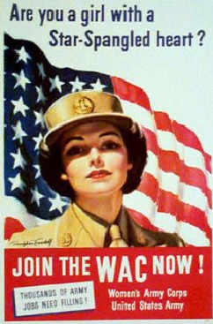

What does this poster indicate about involvement in World War II for the United States?
- Military service was a profitable career for women
- Protecting the home front was a public obligation for women
- Political participation was a citizenship requirement for women
- Assisting the military mission was a patriotic action for women

- One of the main effects of the passage of the Interstate Highway Act of 1956 was the expansion of
- Ridership on long-distance passengers trains
- Immigrant populations
- Communities in the suburbs
- The airline industry

- Why was post-World War II Berlin, Germany, different from other Cold War areas of conflict?
- East Berlin was founded on a free market economy
- West Berlin was located within a communist country
- West Germany was compelled to build a wall to deter the Soviet Union
- East Germany was obligated to send an ambassador to the United Nations

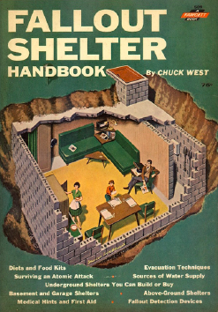

The shelter pictured in this handbook was designed to help Americans survive
- Global climate changes
- Pandemic disease
- Natural disasters
- Nuclear war

- How did President Harry Truman’s decision to desegregate the military affect African Americans?
- It highlighted racial discrimination outside the military.
- It highlighted affirmative action plans outside the military.
- It affirmed the practice of race-based promotions in the military.
- It encouraged the prosecution of race-based discrimination in the military.

- In 1949 twelve nations signed a treaty to form the North Atlantic Treaty Organization (NATO).

Which statement provides an accurate analysis of how NATO increased Cold War tensions?
- The alliance established an embargo against Eastern European goods.
- The agreement mandated the disarmament of Western European countries.
- The agreement encouraged United States involvement in Eastern European affairs.
- The pact created a mutual defense alliance between the United States and Western European countries.
- Which statements evaluate the impact of the Voting Rights Act of 1965 on democratic participation?
- The act succeeded because it allowed more citizens to vote.
- The act succeeded because it increased voting qualifications.
- The act failed because it did not loosen requirements for gaining citizenship.
- The act failed because it did not anticipate loopholes in legislative guarantees.

- This list describes several events during the Civil Rights Movement.

What do these events indicate about the government response to the Civil Rights Movement?
1957- Federal troops enforce integration of an Arkansas high school.

1964- Civil Rights Act forbids discrimination in public facilities.

1965- Voting Rights Act forbids literacy test for voters.

- The federal government continued to encourage social activism.
- The state government actively upheld constitutional protections.
- The state governments continued to promote political participation.
- The federal government actively secured constitutional guarantees.

- Why did leaders of the Civil Rights Movement oppose the use of poll taxes?
- The tax funds for political candidates.
- The tax offset reductions in property ta rates.
- The tax used political participation to raise funds.
- The tax used economic ground to exclude voters.

- In 1957 this telegram was sent to President Dwight Eisenhower from the Mayor of Little Rock, Arkansas.
The immediate need for federal troops is urgent. The mob is much larger in numbers at 8am than at any time yesterday… Situation is out of control and police cannot disperse the mob…Action by you restore peace and order and compliance with your proclamation.
Why was it important for the federal government to respond to this situation?
- The federal government wanted to appease voters in Southern states.
- The federal government needed to demonstrate it would enforce the law.
- The federal government wanted to promote political participation in Southern states.
- The federal government needed to prove it would halt protest by civil rights activist.

- Which statement became a slogan for the Civil Rights Movement following the March on Washington in 1963?
- “I have a dream!”
- “A Brave New World”
- “Give Peace A Chance”
- “Back to the drawing board”

- Which constitutional issue was debated after the release of the Pentagon Papers?
- Freedom of religion
- The right to a jury trial
- Freedom of the press
- The right to peaceful assembly

- President John F. Kennedy’s domestic agenda was known as the
- The Great Society
- New Frontier
- Space Race
- New Deal

- The Tet Offensive demonstrated to Americans that
- The Vietcong won a major victory.
- The Vietcong War was almost over.
- The Vietcong was stronger than expected.
- Their soldiers pillaged and burned villages.

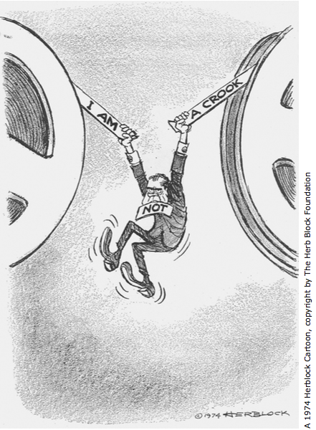

The incident illustrated by this cartoon increased cynicism toward the U.S. government because
- The press secretary failed to keep the public informed of national policy changes.
- The president directed a conspiracy to mislead the nation.
- The Supreme Court overruled statutes that defined confidentiality.
- Congress failed to pass legislation enforcing protection of privacy rights.

- A major goal of President Lyndon B. Johnson’s Great Society program was to
- Reduce poverty in the United States.
- Create a space program.
- Cut domestic programs to balance the budget.
- Contain communism in Southeast Asia.

- Which region has contributed the most to immigration to the United States in the 21st century?
- Latin America
- Southeast Asia
- Eastern Europe
- The Middle East

- The bombing of the World Trade Center in New York City in 1993 was an example of the growth of which of the following issues at the end of the 20th century?
- Genocide
- Poverty
- Terrorism
- Pollution

- Which of the following resulted from the U.S.-led military coalition’s engagement in the Persian Gulf War?
- The Shah of Iran was overthrown.
- Saddam Hussein was forced from power.
- The nation of Kuwait was liberated.
- Iraqi Kurds were granted equal rights.

- How have computer technology entrepreneurs such as Steve Jobs and Jeff Bezos most directly affected the twenty-first-century economy?
- More people are able to shop for goods online
- Restaurant owners are able to open fast-food franchises overseas
- More people are able to get hired after graduating from high school
- Bankers are able to offer customized loans for potential home buyers

